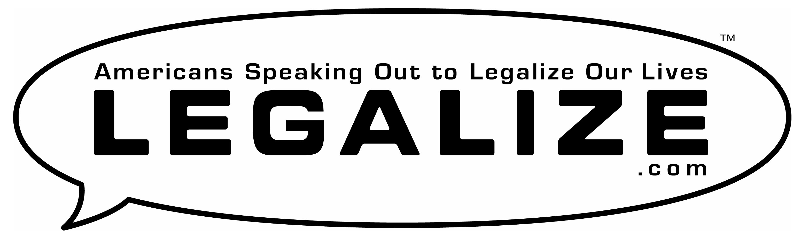

Empower Youth

Groom a new generation of leadership
to provide young Americans a voice in politics.

Petitions ● Flyers ● T-Shirts ● Campaigns ● Lobby Days ● Activism

